**Increase Analog Pins for NodeMCU using 16-Channel Analog Multiplexer Module**

Analog pins are used to measure sensors values. It can record a wide range of values compared to Digital pins that are just provide ON/OFF state. By conventional method, each Analog Input pin that is measured by micro controller is only allow to connected and measured from one sensor. If you need to measure values from two sensors (for example, temperature & sun light intensity), you will need to occupy 2 analog input pins at the micro controller.

NodeMCU is a very famous micro controller board with a built-in WIFI module. It is not only an affordable micro-controller, but it also can do a lot of stuff especially for Internet of Thing (IOT) application. The two most common IOT applications are smart home automation such as button-controlled loads through remote execution & monitoring. IOT is also very famous for real time sensor value online display while data-log the historical value on the web server and we can access those data whenever we want.

However, the biggest disadvantage of the NodeMCU board is that it has only one Analog pin. In other words, it only can measure from 1 sensor. If we have projects that require more than one sensor, we will need to find another micro-controller with more Analog Pins such as Arduino UNO or MEGA. But the boards normally exclude built-in Wi-Fi modules which may need an additional wiring and Wi-Fi module.

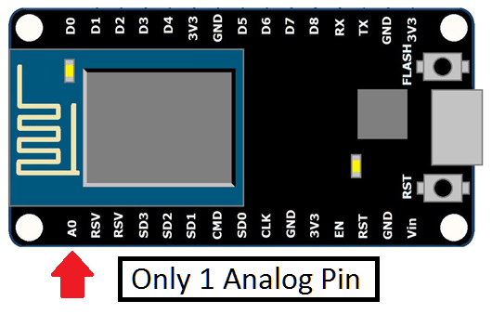

Today we will be using another method which is using an expansion board called Analog Multiplexer Module. It is a microchip that requires 2 to 4 Digital Pins and 1 Analog Pin to convert up to 16 Analog Pins. It may sound complicated at first, but once we know how it works, it will be easy for application.

**NodeMCU micro-controller**

The NodeMCU microcontroller is similar to the Arduino microcontroller board. It is compatible with Arduino IDE software and is built-in with the ESP8266 module which can be connected to the internet.

[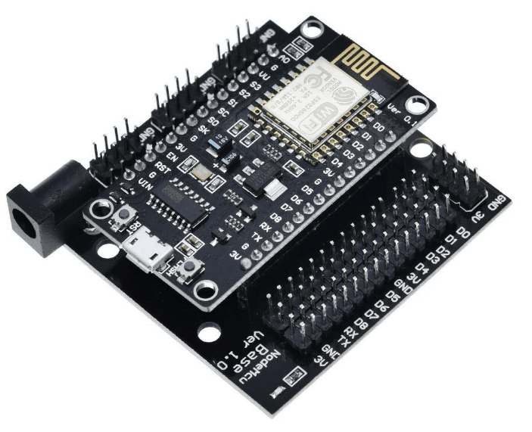](http://s.click.aliexpress.com/e/_dUP917q)

**Node MCU Micro controller Base**

The based below the Node MCU can provide more flexibility on the connection ports to support more sensors. Besides, it also has 12V input port and able to provide 5V power supply to support the sensors.

[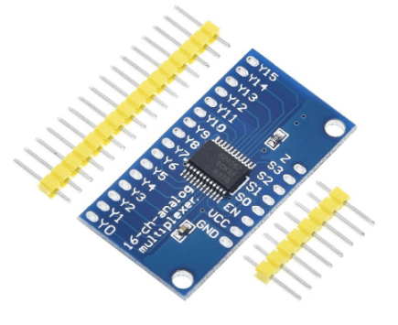](http://s.click.aliexpress.com/e/_d693taw)

**16 Channel Analog Multiplexer Module**

This module is an extension board that allows microcontrollers to have more Analog Pins for sensor measurement. It is very important for NodeMCU as it only has one Analog Pin.

**Multiplexer Module Concept**

A Multiplexer Module is a microchip that requires **1 Analog Pin and 2 to 4 Digital Pins** to allow the micro controller to monitor more Analog Pins for sensor readings. The requirement of 1 Analog Pin is actually the output pin shared among all the extension Analog Pins. The module only allows 1 Analog channel or sensor value to be connected to the output Analog Pin each at a time thus they take turns to operate.

To determine which Analog channel to be opened, Micro controller such as NodeMCU **needs to send Binary command** (a combination of ON/OFF or High/Low) over the Digital Pins to the module so that it allows the selection of the channel to be activated at the specific time. The binary command is operated by the High/Low voltage and each Analog Channel will have its own unique Binary combination. For an example, below is a 16-channel Analog Multiplexer with its Binary Command:

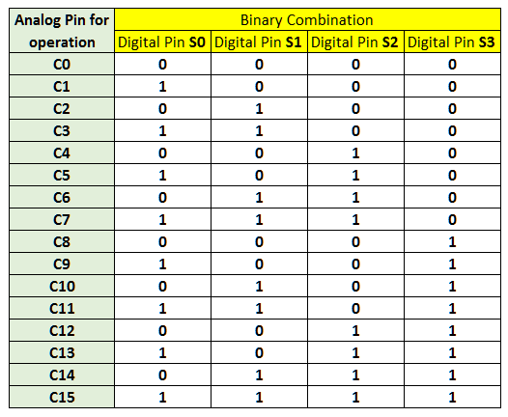

So, for example, if we want to measure channel C15, we can program the 4 Digital Pins High (5V) output to the Multiplexer. In reality, we program the NodeMCU to rotate the output command while measuring each channel output using the same Analog Input A0. The entire process happens so fast and we can get all the 16 channel readings from the module.

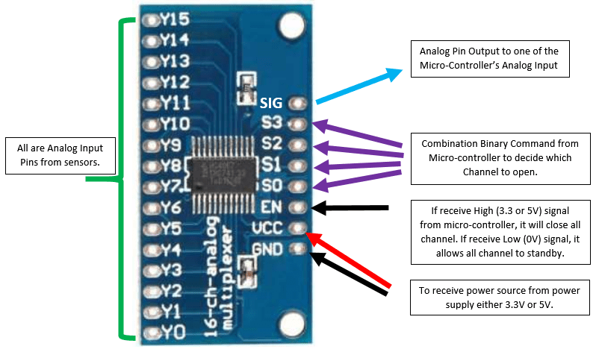

**Hardware Wiring**

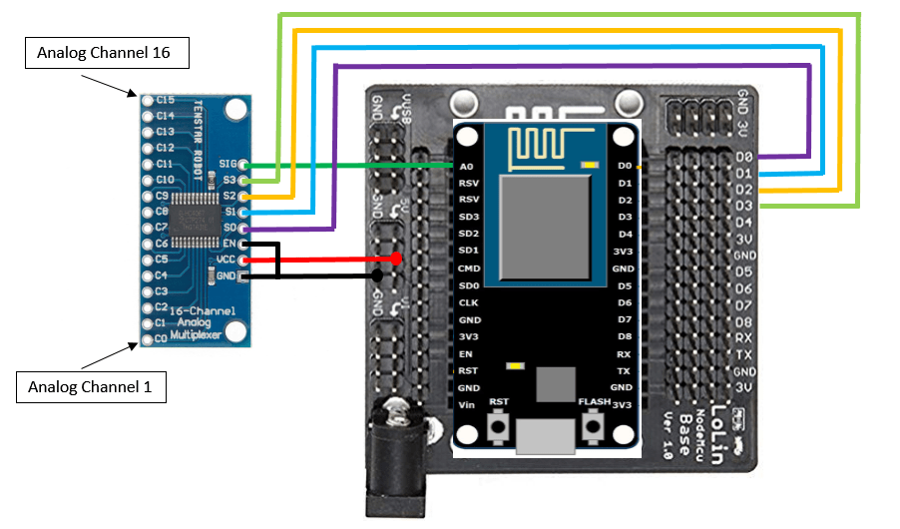

**Wiring Summary**

1 – SIG Analog pin to A0 of NodeMCU

2 – S0 Digital pin to D0 of NodeMCU

3 – S1 Digital pin to D1 of NodeMCU

4 – S2 Digital pin to D2 of NodeMCU

5 – S3 Digital pin to D3 of NodeMCU

6 – EN Digital pin & Ground of NodeMCU

7 – GND Power Supply pin to Ground of NodeMCU

8 – VCC Power Supply pin to 5V of NodeMCU base

9 – C0 to C15 will be analog input pins that can be defined by the user.